**SOFTWARE ENGINEERING ASSIGNMENT**

NAME : JAHNAVI HEGDE

ROLL NO : 21bcs044

**Theme : Create new cultural destination to celebrate the heritage of India and provide a platform for emerging Talents using Digital Technology solutions**

I have created an online ticketing platform. Here people can book tickets of various events related to various art galleries of India.

I have attached the app.py file . This is the main file with all the functionalities. It is connected to a database named ‘art’ which is present in my workbench.

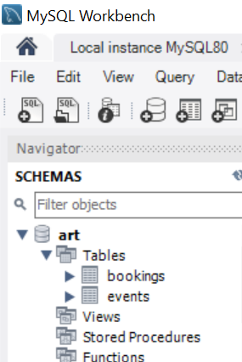This art database has two tables. The bookings table will hold the information regarding the bookings done for an event and the events table will hold the list of events available for booking.

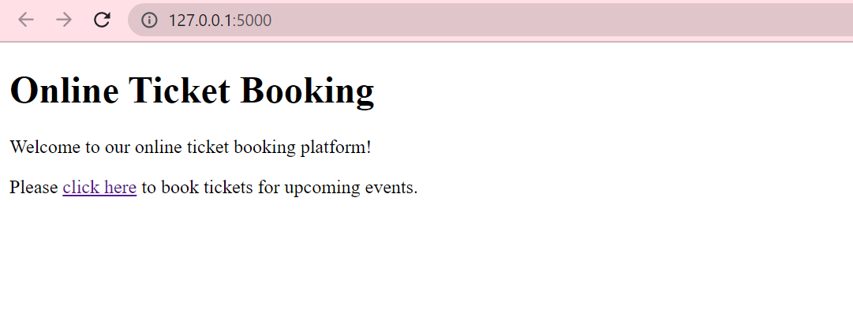

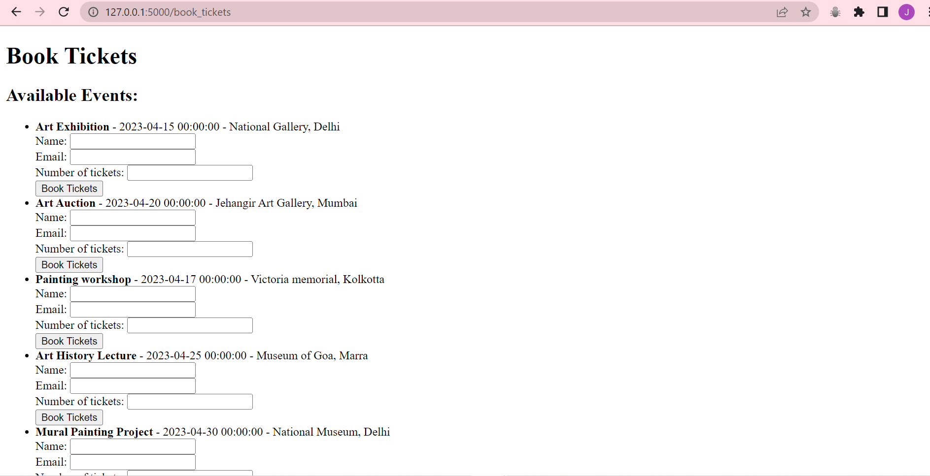

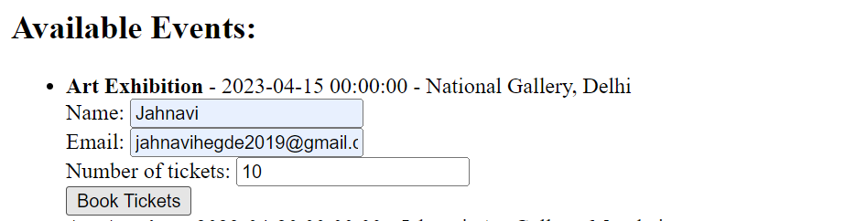

This will get stored in the bookings table.

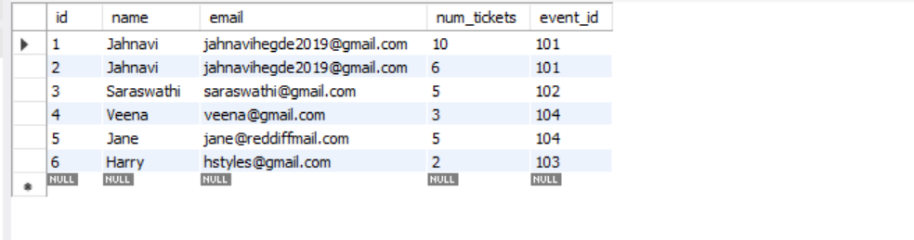

The events can be updated in the events table. The events table looks like this

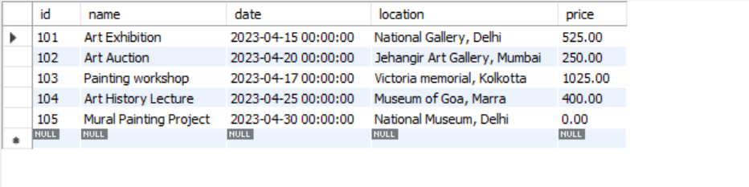

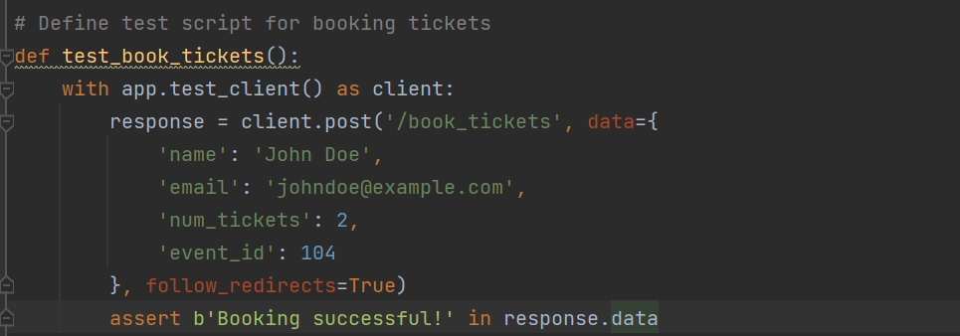

This is the test script for booking tickets. When this function is called a booking should be done under John Doe and this will confirm that everything is working just fine.

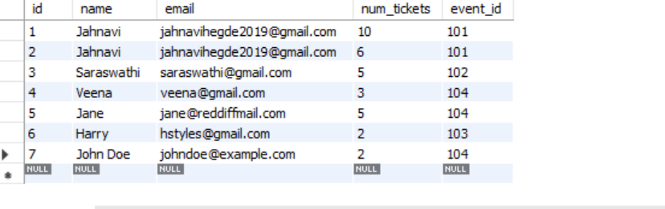

This concludes Integration testing.